1. INTRODUCTION
   1. Purpose

The main objective of the project is to create and design an interactive game that applies data networking concepts so that the students will gain knowledge and experience about computer networks such as socket programming.

* 1. Document Conventions

In this document, the Clash of Clans will be referred to as COC, the Townhall will be termed as TH, the medium for transaction as LOOTS, and the clan castle as CC. All new terms that will be stated in this document will be in bold.

* 1. Intended Audience and Reading Suggestions

This document is intended for project manager, developers, and testers who will use the system.

* 1. Product Scope

The project is intended to give the students an opportunity to learn and gain knowledge about data networking, and will be further used by the professor as a basis to determine if the objective of the course has been fulfilled.

* 1. References

Wiegers, K.E. (1999). Software Requirements Specification (SRS) Template.

1. OVERALL DESCRIPTION
   1. Product Perspective

The project will be a model of the already existing Clash of Clans mobile application. However, this does not intend to contain all of the functionalities and features of the said game, but will focus more on applying the computer networking concepts.

* 1. Product Functions

Character Details

|  |  |  |  |  |  |  |  |  |
| --- | --- | --- | --- | --- | --- | --- | --- | --- |
|  | **Preferred Target** | **Attack Type** | **Movement Speed** | **Attack Speed (s)** | **Quantity** | **Range (tiles)** | **Damage per second** | **Hitpoints** |
| **Barbarian** | None | Melee | 16 | 1 | 20 | 0.4 | 23 | 95 |
| **Archer** | None | Ranged | 24 | 1 | 17 | 3.5 | 20 | 40 |
| **Goblin** | Resources (Damage x2) | Melee | 32 | 1 | 18 | 0.4 | 32 | 64 |

Building Details

|  |  |  |  |
| --- | --- | --- | --- |
|  | **Quantity** | **Hitpoints** | **Damage per second** |
| **Town Hall** | 1 | 2,400 | 0 |
| **Barracks** | 6 | 420 | 0 |
| **Walls** | 80 | 1,400 | 0 |
| **Cannon** | 5 | 620 | 25 |

* 1. User Classes and Characteristics

The system has only one type of user – the players. These players will gain access to all functions and features of the model application. Nevertheless, they do not have access to the back-end of the program.

* 1. Operating Environment

The software is programmed to be a desktop application compatible with computers on any operating system.

* 1. Design and Implementation Constraints

The project will be programmed using Java for the front-end and C for the back-end.

* 1. User Documentation

This document along with an additional user manual will be delivered upon completion of the project in order to guide the users in using the software.

* 1. Assumptions and Dependencies

The program is assumed to be used only by the programmers within the laboratory and is not intended for outside deployment.

1. EXTERNAL INTERFACE REQUIREMENTS

3.1

3.2

3.3 Software Interfaces

The system uses the following software/libraries in its implementation and usage.

* Java
* C
* Eclipse IDE

1. EXTERNAL INTERFACE REQUIREMENTS

Initially, when a user connects to the server, he will be assigned a randomized base to be chosen from the four formats below. The dark green border serves as the walls of the base, the blue squares as the cannon, brown boxes are the barracks and the red box serves as the town hall.

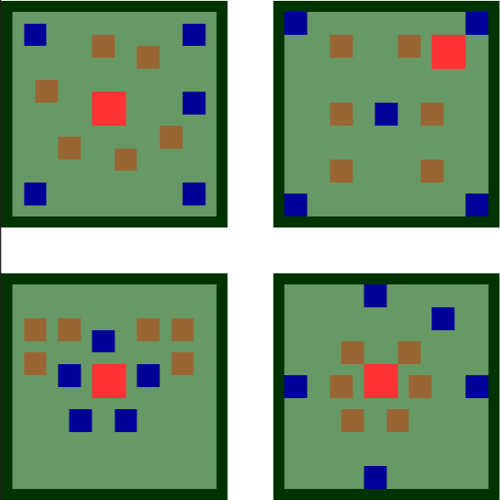

Figure 1 shows the layout of the 4 initial bases to be used in the COC model

1. OTHER NON FUNCTIONAL REQUIREMENTS
   1. Safety Requirements

As a standard, players are discouraged to share their passwords among other players for it may result to account hacking.

* 1. Security Requirements

The system has no security requirements since anyone can make an account and gain access to the game.

* 1. Software Quality Attributes

The software is required to be able to connect at least three players at any given time provided that all players are logged in to their accounts.

1. OTHER REQUIREMENTS

**Appendix A: Glossary**

COC

an acronym for the Clash of Clans mobile application

TH

an acronym for the Townhall building in COC

LOOTS

term to be used as a medium for transaction while inside the game

CC

an acronym for the Clan Castle building in COC

Java

programming language to be used for the front-end of the system

C

programming language to be used for the back-end of the system

**Appendix B: User Manual**